Stakeholder Analysis Report: AutoPrice AI

Executive Summary
AutoPrice AI is a data-driven used vehicle price prediction system specifically optimized for European markets, incorporating environmental and regulatory factors. This stakeholder analysis aims to identify, prioritize, and develop engagement strategies for all parties impacted by this solution. Success requires navigating a complex ecosystem of individual users, commercial entities, and regulatory considerations. The analysis provides actionable insights for product development, go-to-market strategy, and risk mitigation in the competitive automotive pricing intelligence landscape.
1.0 Introduction and Methodology
The European used vehicle market suffers from pricing opacity and inconsistency, exacerbated by varying emission regulations and market fragmentation. AutoPrice AI addresses this by providing transparent, regulation-aware pricing intelligence. This analysis systematically examines stakeholders using:
- Identification: Cataloging all entities affected by or influencing the product
- Categorization: Mapping stakeholders by influence, interest, support, and impact
- Strategy Development: Creating tailored engagement approaches
Primary analytical tools include the Influence-Interest Matrix and Support-Impact Matrix.
2.0 Stakeholder Identification and Categorization
Table 1: Internal Stakeholders
Stakeholder Group | Primary Interests & Concerns
Executive Leadership / Investors | Market penetration in Europe, revenue growth, competitive positioning, regulatory compliance, scalability
Product Management & Development | Algorithm accuracy, European market specificity, integration flexibility, data quality, regulatory updates
Sales & Marketing Teams | Clear differentiation from generic pricing tools, target segment identification, commission structure, competitive intelligence
Data Science & Analytics Team | Model accuracy, feature engineering for European factors, explainability of LLM-based reasoning, data pipeline robustness
Table 2: External Stakeholders
Stakeholder Group | Primary Interests & Concerns
Primary Users: Dealerships & Sellers | Pricing accuracy, ease of integration, time savings, competitive advantage, trust in predictions
Economic Buyers: Fleet Managers & Marketplace Platforms | Cost savings, operational efficiency, integration with existing systems, ROI, data reliability
End Users: Individual Buyers/Sellers | Fair price assurance, transparency, ease of use, cost (if applicable), trust in platform
Technical Integrators: IT Departments & Platform Developers | API reliability, data security, scalability, documentation quality, compliance with data protection (GDPR)
Influencers: Automotive Industry Experts & Journalists | Accuracy of methodology, independence from dealer bias, transparency of algorithm, regulatory alignment
Strategic Partners: Dealer Management System Providers | Integration opportunities, revenue sharing, co-marketing, technical compatibility
Regulatory Bodies: EU Environmental Agencies | Compliance with emission standards, accuracy of environmental factor integration, transparency
Competitors: Existing Pricing Tools | Market response, feature parity, pricing pressure, differentiation strategies
Data Providers: Vehicle History & Market Data Companies | Data licensing opportunities, partnership potential, data accuracy requirements
3.0 Stakeholder Analysis Matrices
Matrix 1: Influence vs. Interest Analysis
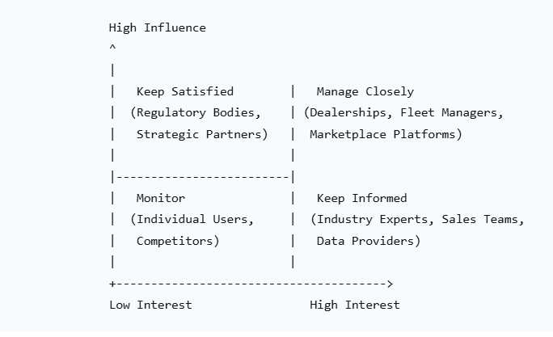
*Figure 1: Influence-Interest Matrix for AutoPrice AI Stakeholders*
High Influence, High Interest (Manage Closely)
- Dealerships & Marketplace Platforms: Direct customers with significant buying power and high interest in accurate pricing
- Fleet Management Companies: Large-scale users with complex needs and substantial influence on market adoption
- Executive Leadership: Critical for strategic direction and resource allocation
High Influence, Low Interest (Keep Satisfied)
- Regulatory Bodies (EU Environmental Agencies): Can impose compliance requirements but may have low daily interest
- Strategic Partners (DMS Providers): Can enable or block integration but focused on their own product roadmaps
Low Influence, High Interest (Keep Informed)
- Individual Buyers/Sellers: Highly interested but limited market influence individually (though collectively significant)
- Industry Experts & Journalists: Can shape market perception but don't control adoption
- Sales & Marketing Teams: Critical for execution but limited strategic influence
Low Influence, Low Interest (Monitor)
- Competitors: Monitor for market moves but limited direct engagement needed
- Data Providers: Important but transactional relationships
Matrix 2: Support vs. Impact Analysis
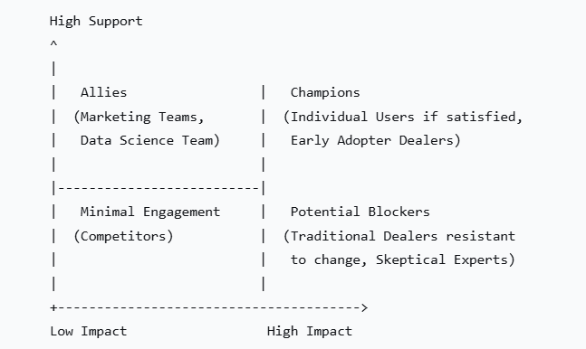
*Figure 2: Support-Impact Matrix for AutoPrice AI Stakeholders*
High Support, High Impact (Champions)
- Early Adopter Dealers: Those embracing digital transformation can become powerful advocates
- Satisfied Individual Users: Can drive word-of-mouth and platform credibility through reviews
High Support, Low Impact (Allies)
- Internal Teams (Marketing, Data Science): Naturally supportive but impact limited to their functions
- Technology Partners: Supportive of innovation but impact varies by partnership scale
Low Support, High Impact (Potential Blockers)
- Traditional Dealerships: May resist transparent pricing that reduces negotiation advantages
- Skeptical Industry Experts: Can undermine credibility if concerns about methodology aren't addressed
Low Support, Low Impact (Minimal Engagement)
- Direct Competitors: Naturally opposed but engagement should be limited to market monitoring
4.0 Detailed Engagement Strategies & Communication Plan
Table 3: Engagement Strategy for High-Priority Stakeholders
Stakeholder Group | Key Messages | Communication Channels | Engagement Frequency
Dealerships & Commercial Sellers | "Increase profit margins by optimizing pricing strategy"  "Reduce days on lot with market-aligned pricing"  "Stay compliant with evolving EU emission regulations" | Direct sales, trade shows, dealership associations, case studies, ROI calculators | Monthly check-ins for active clients; quarterly newsletters for prospects
Marketplace Platforms | "Enhance user trust with transparent, data-driven pricing"  "Reduce transaction friction with fair price benchmarks"  "Differentiate your platform with EU-specific compliance features" | Executive briefings, API documentation, integration workshops, co-marketing opportunities | Quarterly business reviews; as-needed technical support
Fleet Management Companies | "Optimize total cost of ownership with accurate residual value predictions"  "Simplify compliance reporting with integrated emission tracking"  "Make data-driven decisions on vehicle replacement timing" | Industry conferences, fleet management associations, whitepapers, customized demos | Bi-annual strategic reviews; monthly operational updates
Regulatory Bodies (EU Agencies) | "Our tool promotes market transparency and environmental compliance"  "We incorporate official emission standards into our valuation models"  "We support the EU's green transition objectives" | Industry consultation responses, whitepapers on methodology, conference presentations | Annual updates; participation in relevant consultations
5.0 Risk Assessment and Mitigation
Table 4: Key Stakeholder-Related Risks and Mitigations
Risk | Description | Affected Stakeholders | Mitigation Strategy
Algorithm Skepticism | Users distrust AI-generated prices compared to human "expert" judgment | Dealers, Individual Users, Industry Experts | Transparency Strategy: Provide "explainable AI" features showing weighting factors. Publish accuracy metrics. Offer hybrid models combining statistical and LLM approaches.
Integration Complexity | Difficulties integrating with diverse dealer management systems and platforms | Technical Integrators, Marketplace Platforms | Technical Strategy: Develop comprehensive, well-documented APIs. Offer SDKs for major platforms. Provide sandbox environments for testing. Establish partner certification programs.
Regulatory Non-Compliance | Failure to accurately incorporate or update for changing EU emission standards | Regulatory Bodies, Fleet Managers, All Commercial Users | Compliance Strategy: Establish regulatory monitoring process. Implement automatic updates for regulation changes. Create compliance validation reports for users.
Market Fragmentation | Significant regional price variations within Europe reducing model accuracy | All Users, Particularly Cross-Border Operators | Product Strategy: Develop region-specific models for major markets (DACH, Benelux, Nordic, etc.). Clearly communicate geographic limitations. Offer region-specific accuracy metrics.
Data Privacy Concerns | Handling of sensitive vehicle and transaction data under GDPR | Technical Integrators, Regulatory Bodies, Users | Security Strategy: Implement privacy-by-design architecture. Offer both cloud and on-premise deployment options. Obtain relevant certifications. Provide transparent data handling policies.
Table 5: Success Metrics by Stakeholder Group
Stakeholder Group | Key Success Metrics | Measurement Approach
Dealerships | Increased profit margins, Reduced inventory days, Higher transaction completion rates | Case studies, ROI analysis, Customer surveys
Marketplace Platforms | Increased user trust scores, Higher transaction volumes, Reduced price disputes | Platform analytics, User feedback, Dispute resolution metrics
Individual Users | Price satisfaction scores, Willingness to recommend, Accuracy perception | Post-transaction surveys, NPS scores, Review ratings
Fleet Managers | Improved residual value accuracy, Compliance reporting efficiency, TCO optimization | Historical vs. predicted value analysis, Time savings metrics
Regulatory Bodies | Market transparency improvements, Emission compliance rates | Market analysis reports, Compliance audit results
Investors | Revenue growth, Market penetration, Customer retention | Financial reporting, Market share analysis, Churn rates
6.0 Conclusion and Recommended Actions
AutoPrice AI operates at the intersection of automotive commerce, regulatory compliance, and artificial intelligence. The stakeholder landscape is characterized by:
- Diverse User Needs: Ranging from individual consumers to large commercial enterprises
- Regulatory Complexity: Navigating evolving EU environmental standards
- Market Fragmentation: Addressing significant regional variations within Europe
- Trust Barriers: Overcoming skepticism toward AI-driven pricing in a traditionally relationship-driven industry
Critical Success Factors:
- Establish Credibility: Through transparent methodology and demonstrable accuracy across diverse European markets
- Build Strategic Partnerships: With dealer management systems and marketplace platforms to accelerate adoption
- Maintain Regulatory Agility: To adapt quickly to changing EU environmental standards
- Balance Transparency: Providing enough insight into pricing logic to build trust without revealing proprietary algorithms
Immediate Next Steps:
- Establish a European Advisory Board with representatives from dealerships, fleet management, and regulatory experts
- Develop a phased market entry strategy starting with Belgium and expanding to neighboring markets
- Create differentiated product offerings for individual users vs. enterprise clients
- Implement a continuous regulatory monitoring system to track EU emission standard updates
- Launch a transparency initiative publishing accuracy metrics by vehicle brand and region
By strategically engaging stakeholders according to their specific interests, influence, and concerns, AutoPrice AI can successfully establish itself as the trusted pricing intelligence platform for the European used vehicle market, driving transparency and efficiency while supporting environmental compliance objectives.

Document Prepared By: AutoPrice AI Strategy Team
For: Product Development & Go-to-Market Planning
Confidentiality: Internal Use Only

